|  |  |
| --- | --- |
|  | Premier University Chittagong  Department Of Computer Science & Engineering |

Project Title : Online Tutor Finder System

Course Code : CSE 306

Course Title : Software Engineering & Information System Design Laboratory

Date of Submission : 17/10/20

Sumitted To

**Dhrubajyoti Das**

Lecturer

Department of Computer Science & Engineering.

Premier University Chittagong.

Submitted By

**Israt Jahan Shama**

**Afroja Sultana Riya**

**Rashma Dev**

**(5TH semester)**

**Introduction** : On this we are trying to solve the ongoing problem of finding tutor and tuition. Day by day, the system of education are improved and changed instantly. For this reason, good tutors are badly needed for our society. To solving this problem we are taking a project in hand which is “Online Tutor Finder”. We are trying to make software so that one can easily find tutor and an tutor easily find tuition by one search.

**Objectives** :

* Our core objectives is to make a communication path between student and tutor.
* Our main focused is to make easiest searching so that one can easily find tutor or tuition.
* We are trying to remove a some problem (e.g. : tuition place,salary and miscommunication with parents) which are faced badly some tutor today.
* We aim to make it easy for our students to find the teacher by fulfiling their own needed.

**Literature Review** : I find this type of tutor find system from “Home Tutor Bd” website and trying to implement. They are used this system for searching tutor and find tuition. User as tutor after login they can change their profile and apply for tuition details also and find tuition in their nearest location. User as student after login they can change their profile and apply for tutor. They can publish and tutor gets notified about their circular. An student can also find Educational Institution with their institutional details, address, phone, location map and more. Search the best educational institution from their global educational directory. We are following to design our project on these basis of idea.

**Features :**

* Public User

1. Search Tutor
2. View Post
3. Create User Account (as tutor or as student)

* Student User

1. Search Tutor
2. Publish Circular
3. Apply for teacher
4. Update student’s details

* User as Tutor

1. Find Tuition / Search Tuition
2. View Circular
3. Update Teacher Account and details

**Methodology** :

* **Use Case :**

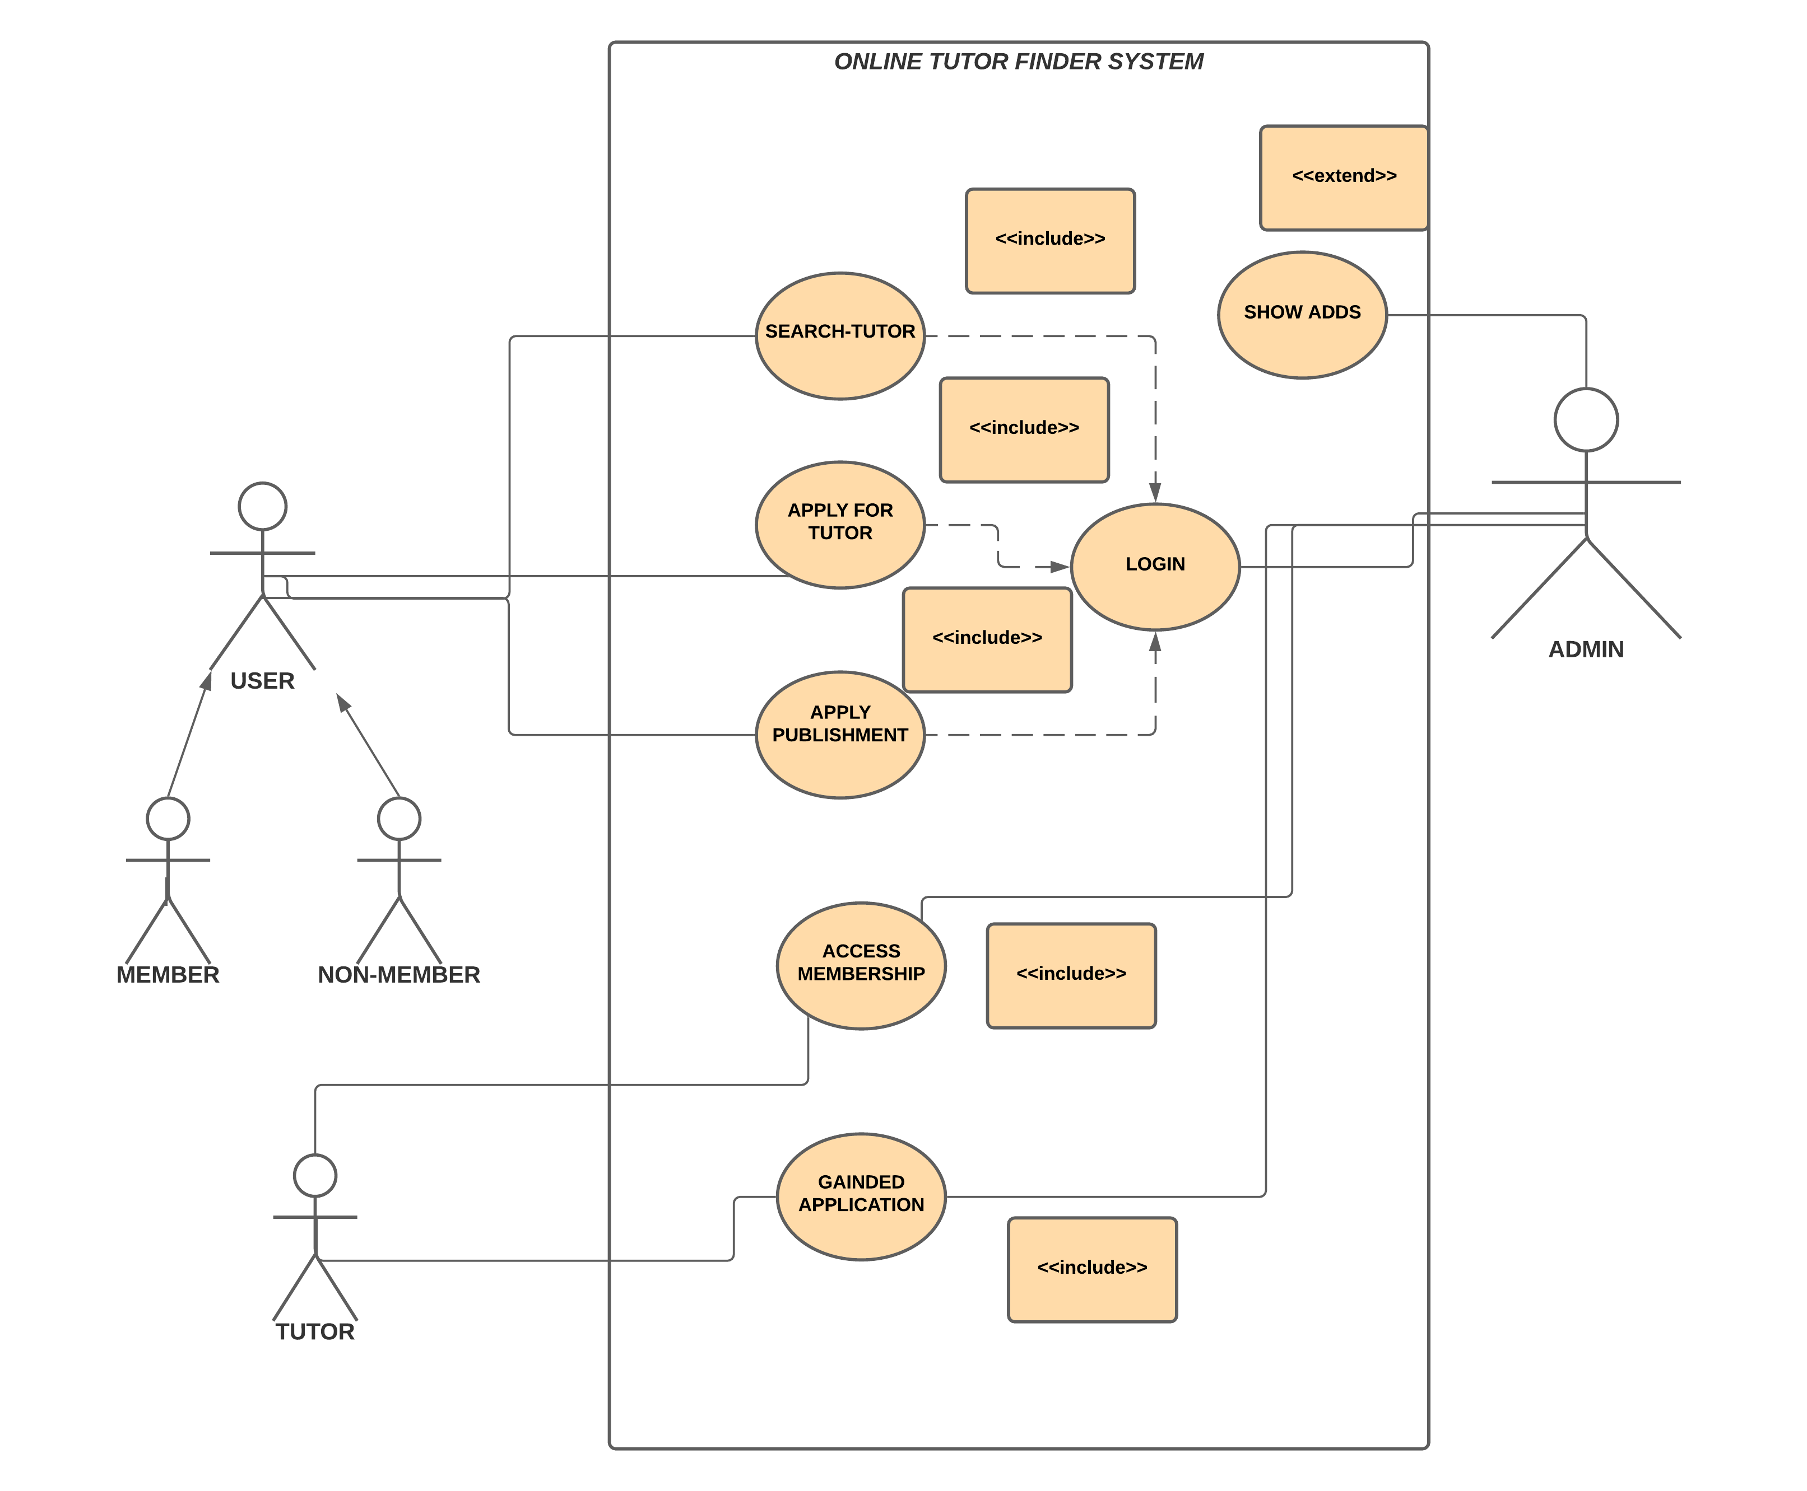

* **Data flow diagram for Online Tutor Finder System :**

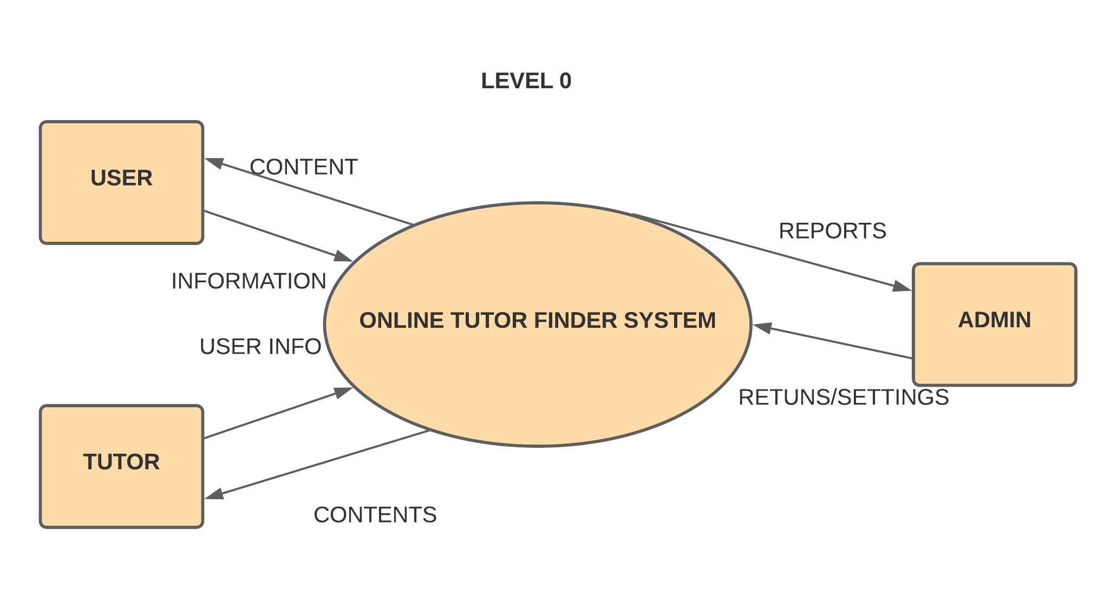

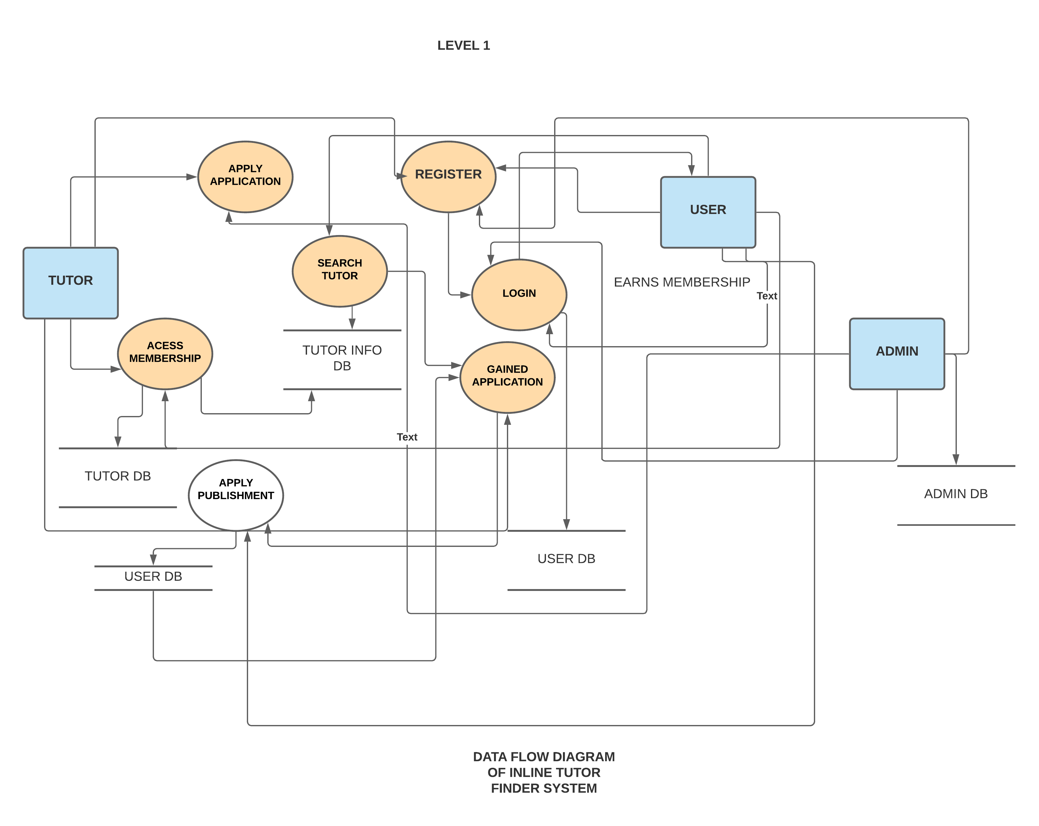

* **Activity diagram for Online Tutor Finder System :**

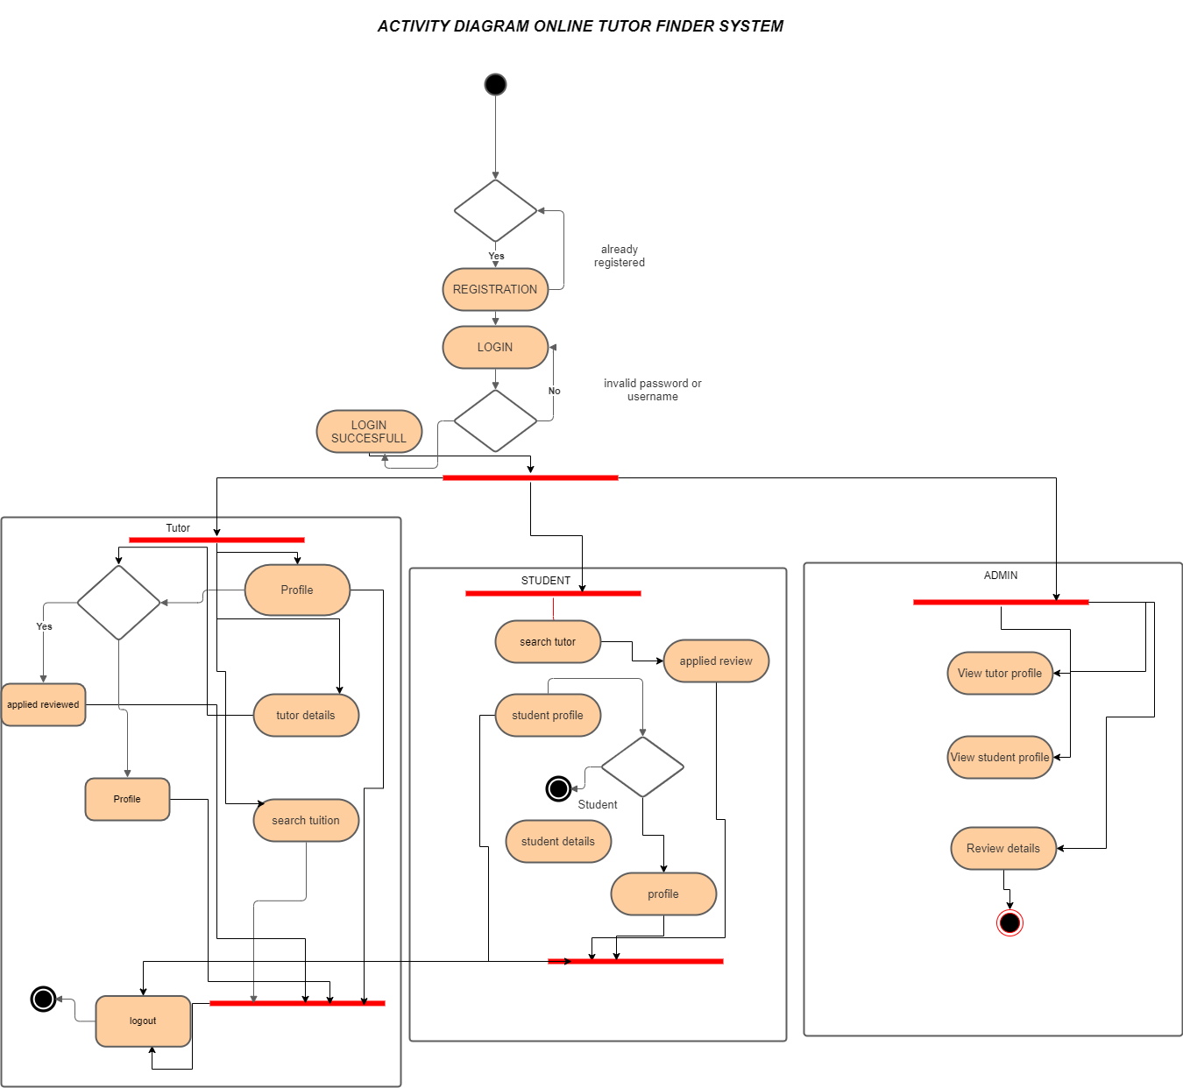

* **ER Diagar**

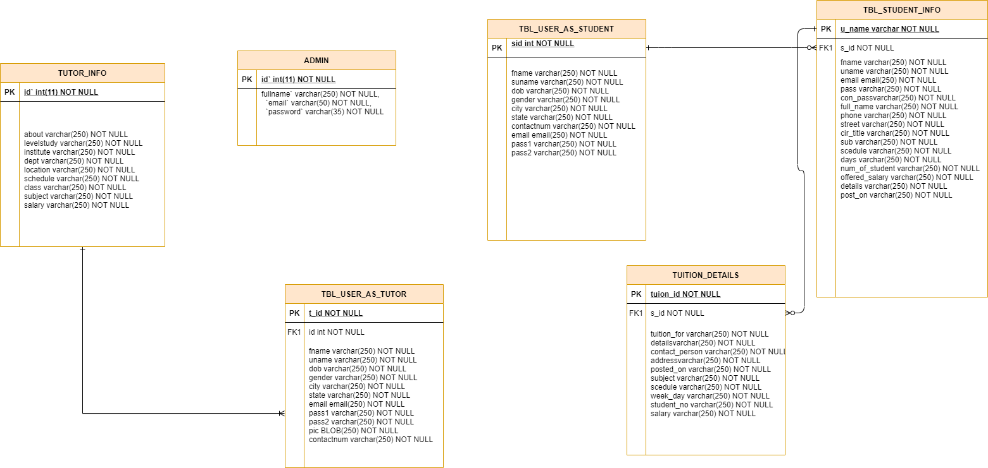

**Process Model :** Internal Model is a process of software development where requirements divide into multiple standalone modules of the software development cycle. In this model , each midule goes through the requirments , design ,implementation and testing phases. Every subsequents release of the module adds function to the previous release.

The process continue until the complete system achived. According to user requirements and process our project is based on incremental model .

**Refference** : Refferences are included from :

<https://hometutorbd.com>

https://bdtutor.com

**Conclusion** : Online Tutor Finder System is a project which focus on connection between the teacher and student.It makes an platform which connect student and teacher. It saves lot of time and make easier to find good tutor for todays children.